**Abstract:**

When we want to go visiting places we are new to, we would not know what places to go and which are good ones that we would like. So, we are building a web app, in which the user will first login and enter his preferences. Each user, once he logs in, will have option to tell what his duration of trip will be, i.e, the dates, and for each day, the time he wishes to go visiting places, the start/end point of the trip and also the type of places he wishes to see that day. Then using this information, if the user has already visited certain places and has given ratings to that place, then using that information, using the rating information for places, average time spent at place, location information stored in the database, we will generate an itinerary for the user. It will contain a map, with the recommended places to visit, in the shortest time possible between places, with the start point the user selects as the destination point as well.

**Introduction:**

Current landscape of tourism travel in India is that if a person wants to visit a place, he can find a few websites which will allow him to search for places around or give recommendations on the places based on his preferences. But say if we have some time constraints, we do not have something that would give us an entire itinerary which would consider our preferences, time constraints, the time to spend at the place etc. and give a map with our itinerary. The user may not know much about the locations of the places, so he can be rest assured that the path we suggest is the most optimal one, thus saving him precious time as well as money. Since the user may also not know the time slot that the place is open to visiting, it is difficult to manually search details about each place and then plan accordingly, or else he may go and visit during wrong hours. So we see that these problems here are actually pretty common, but has not yet been properly addressed.

**Problem definition:**

To provide personalized itinerary for attractions based on user location and preferences

**Generic proposed solution:**

These are the detailed steps of our solution:

1. Database: We are building a database, which is populated by scraping the data from multiple sites like TripAdvisor, Google, which we collect and create a database using MySQL. Since each site will have it's own format of storing data, we are trying to create modules, which are designed specifically for the particular site, but all of the modules give out standard format of data to the database. We are also increasing the level of abstraction, by scraping using code, and making a generic data parser, rather than using tools and manually scrape the data.

2. Recommender engine: We are using the rating data of the place from different sites, number of reviews, data from the user's previous places and his ratings, his current preference, his location and all of this will be assigned weights. Then, we take the weighted average of these scores, and calculate the scores for each place. Then based on the proximity of places, the assigned scores and the time slot that the user is free, we will use a variant of Travelling Salesman algorithm where we try to maximise the weights and create an itinerary, which can be edited by the user.

3. Front end: The UI will consist of a web app, with login to authenticate the user. Then, we take the following inputs from the user:

* Dates of travel
* Time of availability for the day
* Start/end location of travel
* Category of places

Then, we will take inputs and generate a few recommendations, and using those we generate an itinerary, which will be shown on the map, with the list of places on the side. The places not included in the itinerary are also shown, so the user can add/remove places from the itinerary and new itineraries will be generated on the fly.

We can say the project would be complete, when our web app is ready, which is by April 14 with above functionalities and features included.

**Literature survey:**

Most mainstream tourism sites existing today, have certain things that they are capable of doing, as mentioned below:

MakeMyTrip, TripAdvisor: These sites offer a lot of functionalities, like being able to book hotels, air tickets and restaurants. The differences are that, MakeMyTrip is more of travel oriented site, with more options to book travel options like bus and trains, whereas TripAdvisor contains exhaustive knowledge related to places. TripAdvisor can be used to search for places nearby, based on preferences of user, but it is not possible to create an itinerary of places to visit.

Google Now: Google generates recommendations automatically on places nearby once we are in a given location. We can also search based on the type of places we want to see, and it will show places sorted in increasing order of distances from the our current location. There is no option to create an itinerary of places that we would want to see.

Inspirock: Inspirock takes a place as input from the user, and generates an itinerary of places, with option to add or remove places. This is the most similar existing solution, but there are however certain differences, them being:

There is no option to set the start and end time of the trip for the day

User cannot extend the time which is fixed at 6:00 PM in the evening, so rules out places to visit after sunset

The start and end points are different, and cannot be changed by the user

Once an itinerary is created, there is no option to get recommendations to restaurants closer to the place which the user is currently in if the users want to have a break for eating

References:

1. Location-Aware Recommendation Systems by María del Carmen Rodríguez-Hernández, Sergio Ilarri, Raquel Trillo-Lado, Ramón Hermoso - Article 2015

This paper provides a survey on location-aware recommender systems in scenarios involving mobile computing. It describes the fundamentals of recommendation systems, shows the most relevant existing approaches for location aware systems. Then it talks about the current applications of location aware recommender systems in different domains. From this paper, we got an idea of how recommender systems are used in various cases, and how it applies in our case of tourism.

2. The Use of Machine Learning Algorithms in Recommender Systems: A Systematic Review by Ivens Portugal, Paulo Alencar, Donald Cowan - arXiv 2015

This paper presents a review of the literature that analyzes the use of machine learning algorithms in recommender systems and identifies research opportunities for software engineering research. Along with comparing the use of algorithms, it also compares the usage of recommender systems in different domains. From this, we learnt that among the papers that the authors have reviewed on recommender systems, the two most used algorithms were Bayesian and Decision trees. The authors think that this is because of the simplicity of the algorithms, i.e, since they are less computationally expensive. Another important thing that we found was that among the papers, tourism was among the last in the list of domains ordered by the number of papers on them.

3. Web application for recommending personalised mobile tourist routes by D. Gavalas, M. Kenteris, C. Konstantopoulos, G. Pantizou - IET Softw., 2012

This paper deals with the problem of creating personalised recommendations for daily sightseeing itineraries for tourists visiting destinations. Their approach considers selected places of interest that a traveller would potentially wish to visit and derives a near optimal itinerary for each day of visit and the places of potential interest are selected based on stated or implied preferences. Their method enables planning of customised daily personalised tourist itineraries considering user preferences, time available for visiting sights on a daily basis, opening days of sights and average visiting times, using heuristics. This was the most relevant paper for our reference, as the concept of creating itinerary is same, and also many of the features. But they have not given their algorithm, so we will have to develop our own.

**System Requirement Specification:**

**High level architecture diagram**

**Hardware Requirements**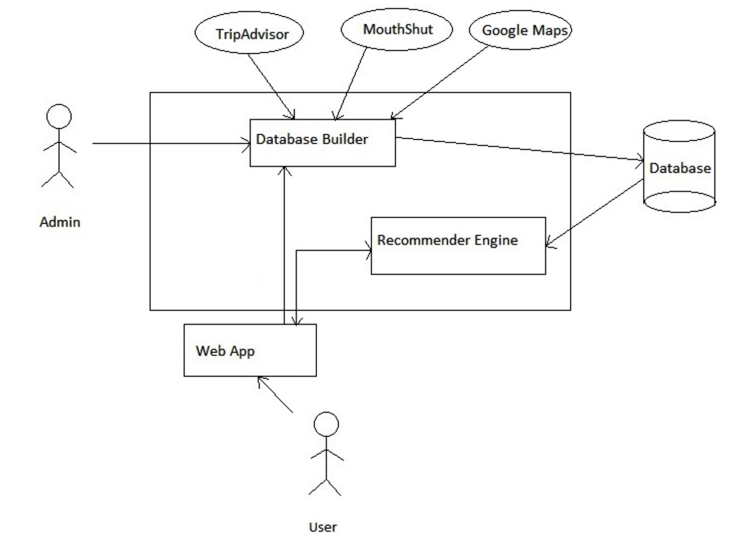

Server - laptop

Client device - laptop, phone

**Software Requirements**

Programming Languages :

Front end: Javascript, HTML, CSS, Bootstrap

Back end:

Server side: PHP

Data extraction: Python

Database: MySQL

Datasources: Google Maps API, TripAdvisor, MouthShut

**Functional Requirements**

FR1 Login page

Description: Login page for user account access.

Evaluation-T1: Manual. We have to create an account and try to login using that account.

FR2 Set trip dates

Description: The dates on which the user intends to go on the trip.

Evaluation-T2: Manual. We have to enter dates of the trip.

FR3 Set location

Description: The place in which user chooses to go around sightseeing other places.

Evaluation-T3: Manual. Location is choses by us, so have to manually choose in the map.

FR4 Set category preferences

Description: Set the type of places the user wants to see.

Evaluation-T4: Manual. Category should be chosen manually.

FR5 A

Description: Set the start and end time for the day.

Evaluation-T5: Manual. Time slots need to be chosen manually.

FR6 Generate itinerary

Description: Create the itinerary on google maps and show user a list of the recommended places.

Evaluation-T6: Manual. See if the generated itinerary is properly displayed on the map

FR7 Add or remove places from recommended list

Description: Give user option to manually add or remove places from the itinerary generated.

Evaluation-T7: Manual. We have to test by manually adding and removing places.

UI1 Provide login page

UI2 Data input page

UI3 Map generation/places recommender page

**Non Functional Requirements**

NF1 Quick data access

NF2 Reliability - Database has ACID properties (MySQL)

NF3 Optimal path generated

**Use case diagrams**

**Requirement Traceability Matrix (RTM)**